Stephan Doan

Creative Coding

Self-assessment

• *Critically analyze/evaluate how much time was spent learning syntax & structure, programming concepts vs. actually programming, and how does this reflect on the final quality of your end result.*

I think there was a decent balance between lecture and programming, which led to a decent final project from me.

• *Comment on your successes and frustrations with Processing and P5.js.*

I don’t quite remember everything about the two languages when I had used them before this course, so my frustrations came from confusing syntax/conventions between these and other languages. I was able to successfully use the documentation for each one.

• *Compare and contrast OOP versus Procedural Programming. How are they similar? How are they different?*

Both utilize something to hold and manipulate data to solve a problem. Procedural programming looks at and manipulates data structures from the “outside” rather than internally, like OOP and its methods and members.

• *Specifically considering your final project: What programming concepts solidified in your final project? What did you learn with reference to programming? Did you have a break through?*

I used many nested if and switch statements to help make the stage structure of my game. I don’t think I necessarily had a breakthrough, but it was still a challenging task.

• *Specifically considering your final project: Were you able to resolve your own bugs? What tricks did you learn in the process to help? Did you do any debugging?*

I worked around them, either by scrapping an idea (a loss screen), or by adapting it (removing pausing between stages in favour of instant progression). I did plenty of debugging with print statements and error message googling.

• *How do you think you'll move forward with programming? will you keep doing it ? How does this relate to other classes you are either taking or wish to take?*

I plan to make plug-ins for the 3D programs I will likely use in my career path, like 3DS Max and Maya. They use different languages, but the core concepts are most likely the same.

IMAGES: (blue arrow is the player)

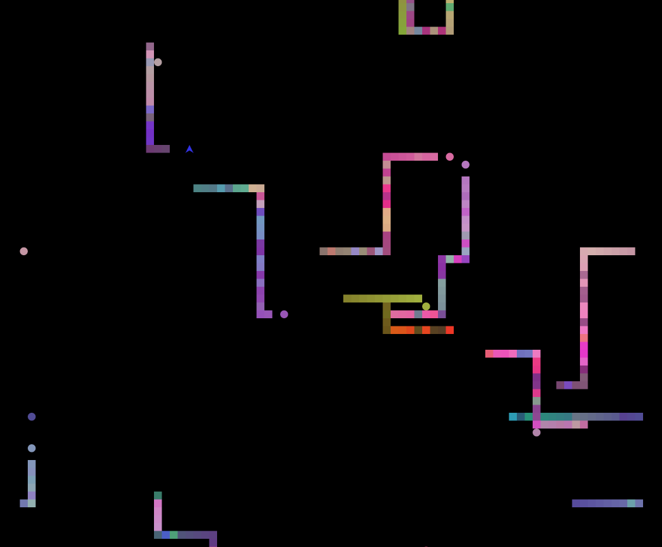

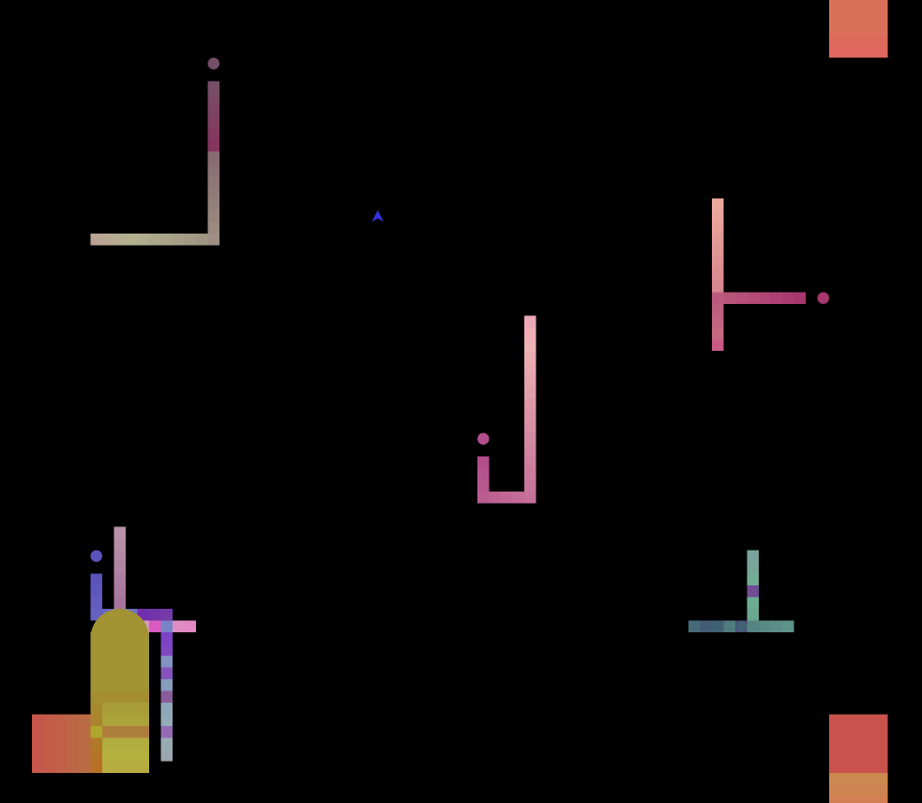

CONCEPT PARAGRAPH:

This project is a simple game, inspired by games like *Tron*, *Snake*, and games from the bullet-hell genre. It’s both interactive and time-based, since the game gets harder and more visuals appear as you play longer. It’s an aesthetic look at the games mentioned above, with a brighter and more chromatic look. At first, I had given it a joke name, but it stuck with the people I showed it to; it’s a combination of *Snake* and *Tron*, so it’s called *Snon*. It’s ridiculous but I’ll keep it.